SkillSwap - Defect Report

DE-001 -Invalid email domain accepted
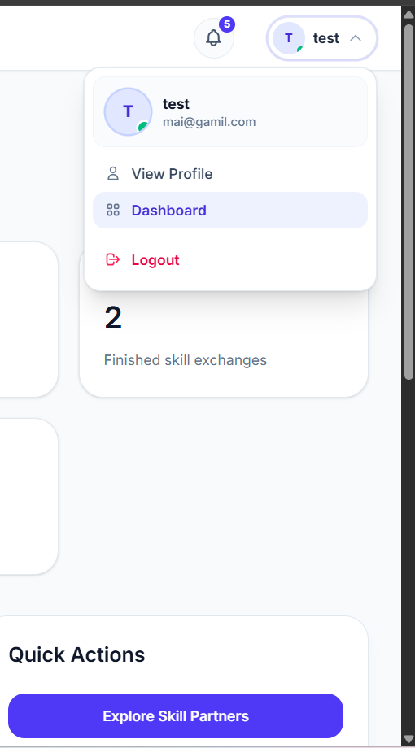

DR-002 -Password mismatch error displayed when both passwords are identical
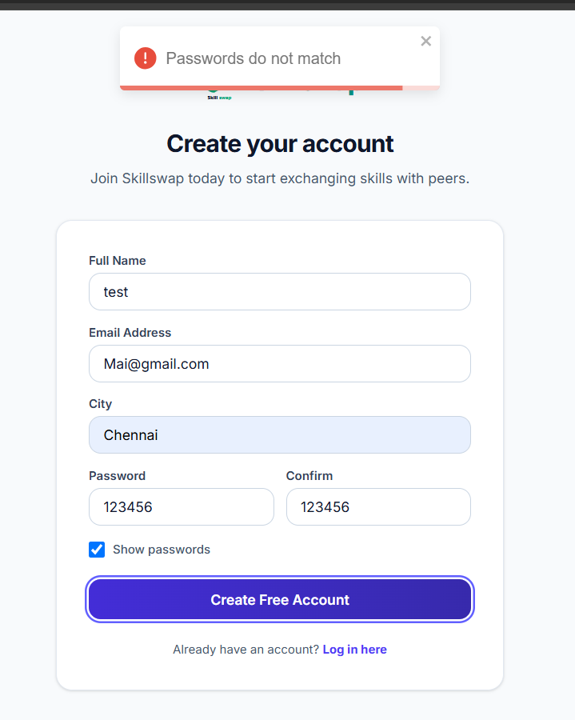

DR-003 -Password reset message is not received by the user
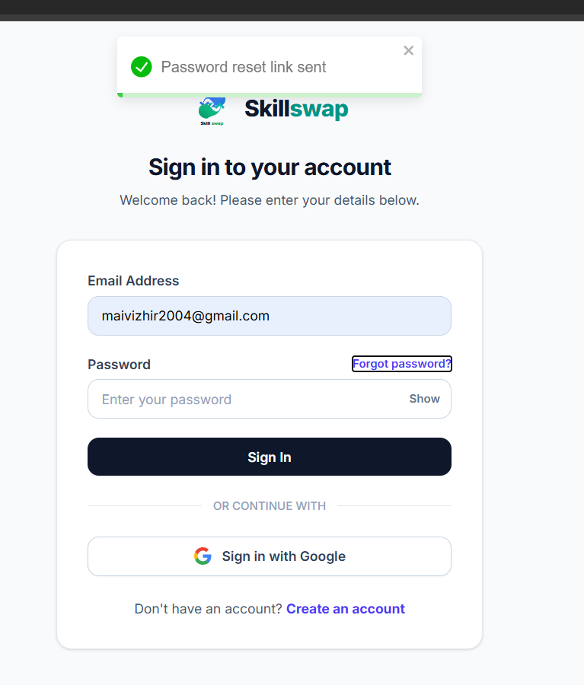
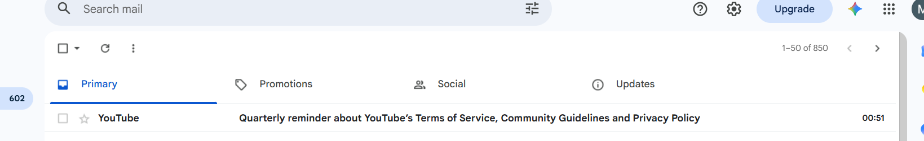

DR-004 - Search does not display an available user/skill

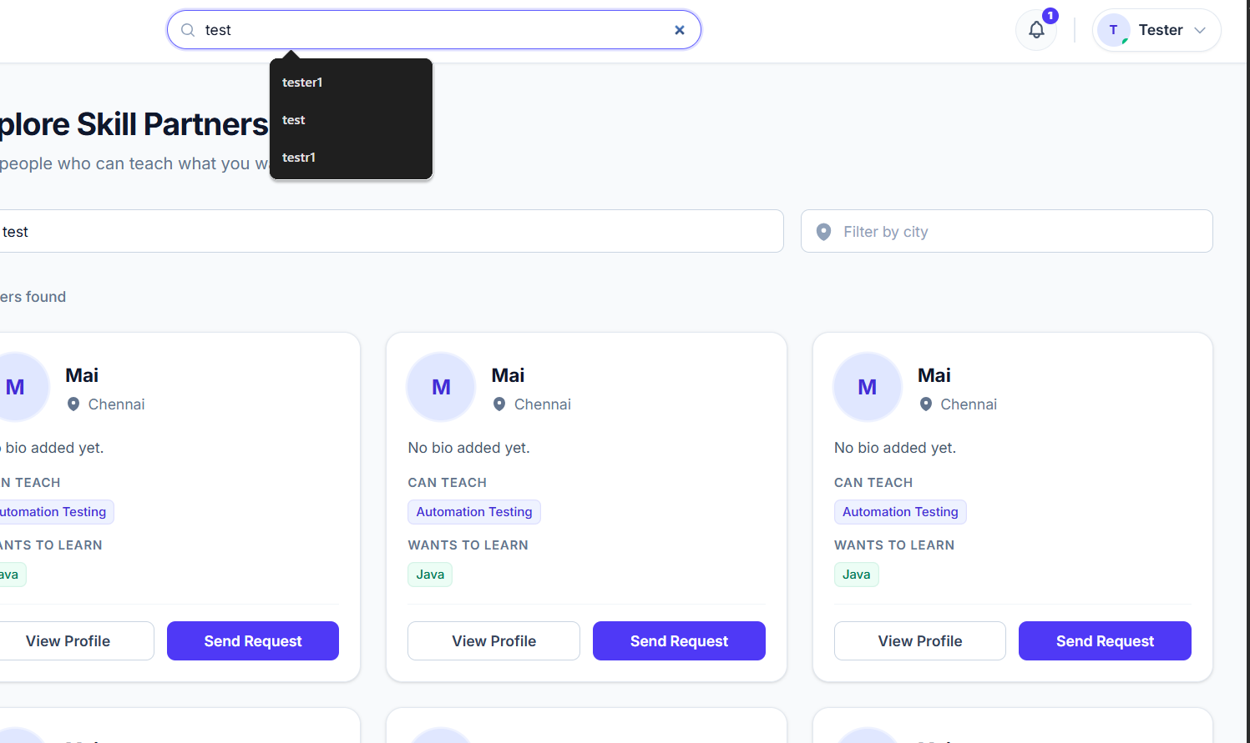

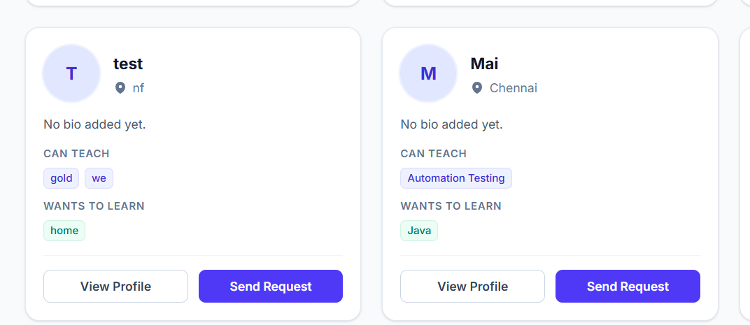

DR-005 -Unable to add profile photo in Edit Profile
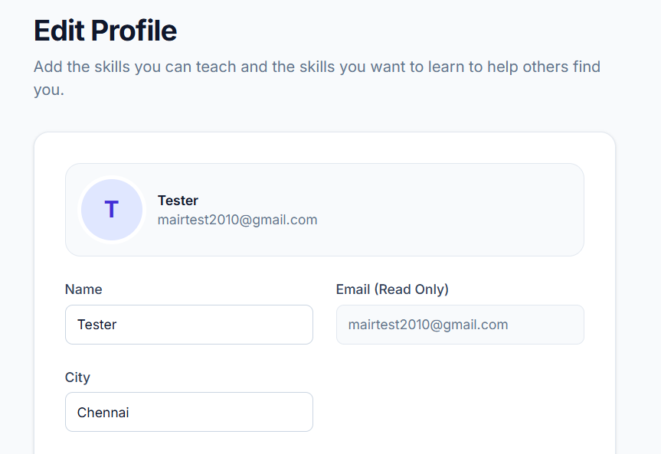
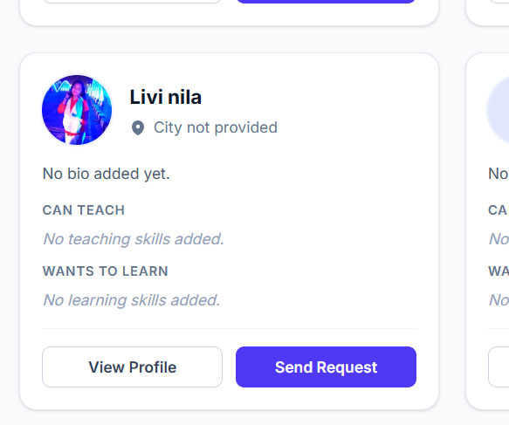

DR-006 -System allows invalid values in the Skills fields

